Brooklyn Navy Yard

63 Flushing Ave, Bldg 12

Brooklyn, NY 11205

IceStone® Product Data

Product description/composition

IceStone durable surfaces are slabs are made from three core ingredients: 100% recycled glass, Portland cement, and non-toxic pigments. Slab content varies per color; please see the content break-down in the table below. IceStone surfaces are fabricated and installed much like a natural stone and can be used in both residential and commercial applications such as tabletops, transaction surfaces, cash wraps, work surfaces, bathroom vanities, counter tops and more.

Manufacturing Plant Location

IceStone LLC, 63 Flushing Ave, Bldg. 12 Brooklyn, NY 11205

Slab Size & Weight

Full Slabs – 52.5” by 96.5” by 1.25” nominal, 16.3 lbs/sq. ft. (approximately 570 lbs/slab)

Colors

IceStone surfaces deliver award-winning design in a range of colors, from contemporary jewel tones to classic neutrals. Custom color development is available for large commercial projects. Please contact us for feasibility and lead times.

Finish

IceStone slabs are shipped from Brooklyn with a polished finish; slabs can also be honed or sandblasted by a fabricator but please check the warranty to see details on covered finishes.

IceStone Slab Content

 | Color |  | Post-Industrial |  | Post-Consumer |  | Post-Consumer Recycled |  | Portland Cement, Pigments,
 |  |  | Recycled Glass |  | Recycled Glass |  | Mother of Pearl |  | & Proprietary Ingredients
 | Alpine White |  | 69% |  | 0% |  | 0% |  | 31%
 | Amber Pearl | 61.2% |  | 0% |  | 7.8% |  | 31%
 | Cobalt Ice |  | 69% |  | 0% |  | 0% |  | 31%
 | Denim Moss | 35% |  | 34% |  | 0% |  | 31%
 | Fogbound |  | 69% |  | 0% |  | 0% |  | 31%
 | Forest Fern | 69% |  | 0% |  | 0% |  | 31%
 | Gotham Grey |  | 61% |  | 8% |  | 0% |  | 31%
 | Latte | 69% |  | 0% |  | 0% |  | 31%
 | Moroccan Red |  | 35% |  | 34% |  | 0% |  | 31%
 | Pearl Grey | 66% |  | 0% |  | 3% |  | 31%
 | Sage Pearl |  | 63.8% |  | 0% |  | 5.2% |  | 31%
 | Sapphire Snow | 66% |  | 3% |  | 0% |  | 31%
 | Sky Pearl |  | 52.8% |  | 11% |  | 5.2% |  | 31%
 | Snow Flurry | 69% |  | 0% |  | 0% |  | 31%
 | Tuscan Sunset |  | 58% |  | 11% |  | 0% |  | 31%
 | White Pearl | 61.2% |  | 0% |  | 7.85% |  | 31%

Note: We do our best to keep this information current and correct. Occasionally, percentages of Pre- and Post-consumer recycled content could shift based on availability and product quality. Percentages are based on weight.

1 of 2

IceStone, LLC T 718 624 4900 F 718 624 4002 E customerservice@icestoneusa.com W www.icestoneusa.com Updated June 2015

Brooklyn Navy Yard

63 Flushing Ave, Bldg 12

Brooklyn, NY 11205

Technical Specifications

Property |  | Test Standard
Compressive Strength |  | ASTM C-109
Flexural Strength |  | ASTM C-203
Specific Gravity |  | ASTM C-97
Porosity/Absorption |  | ASTM C-642
Chemical Durability |  | ASTM C-1260 for ASR
 |  | Reactibility
Freeze Thaw |  | ASTM C-666
Fire Rating |  | ASTM E-84
Coefficient of Static |  | ASTM C-1028
Friction
Food Equipment |  | NSF 51
Materials
Product Certifications

IceStone® Product Data

IceStone Results

13,000 psi – 16,000 psi

890 psi

2.31 g/cm3

0.18% unsealed

0.49% 300 cycles

0.05%

Class 1(A)
Flame spread index 0

Fuel contribution 0
Smoke density index 0

0.69 polished dry/0.61 polished wet
0.71 honed dry/0.62 honed wet

0.85 sandblasted dry/0.77 sandblasted wet

Certified for Splash Zone applications

IceStone is proud to carry the following certifications, which reflect the company's commitment to healthy, sustainable, and innovative design.

IceStone® durable surfaces are Cradle to Cradle Certified™ at the Silver level. Cradle to Cradle Certified™ products are evaluated for material health, material reutilization, renewable energy use and carbon management, water stewardship, and social fairness. To learn more about the Cradle to Cradle Certified™ Products Program, visit www.c2ccertified.org
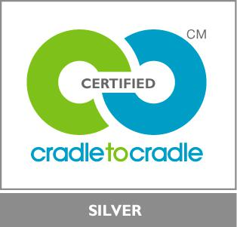

IceStone is also certified by NSF International for NSF/ANSI 51, which indicates IceStone is suitable for use in splash zone applications in food-related establishments, such as decorative salad bars, cashier stations, tray counter areas, etc. To learn more about NSF, visit www.nsf.org.
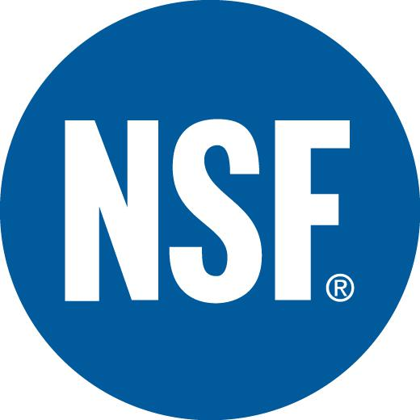

Fabrication & Installation

IceStone surfaces are fabricated and installed similarly to natural stone. Please refer to the IceStone Fabrication Guidelines for more details on the requirements for the fabrication and installation of IceStone.

Maintenance

IceStone is manufactured without any petrochemicals or resins, making it a healthy choice for the home or office. The material is very dense but still porous, so IceStone surfaces do need to be sealed. In general, IceStone is maintained similarly to a natural stone. Please refer to the IceStone Care and Maintenance Guidelines for more detailed information.

Warranty

- Residential 10-Year Limited Warranty and Commercial 10-Year Limited Warranty is available for registered IceStone installations that have been fabricated and installed by an IceStone Certified Fabricator. Some restrictions apply and not all applications are covered. Please view our warranties on our website for detailed terms and conditions. IceStone has a network of certified fabricators across the US and Canada.

To request more information, please email customerservice@icestoneusa.com or call 718.624.4900

2 of 2

IceStone, LLC T 718 624 4900 F 718 624 4002 E customerservice@icestoneusa.com W www.icestoneusa.com Updated June 2015

